Bài 1
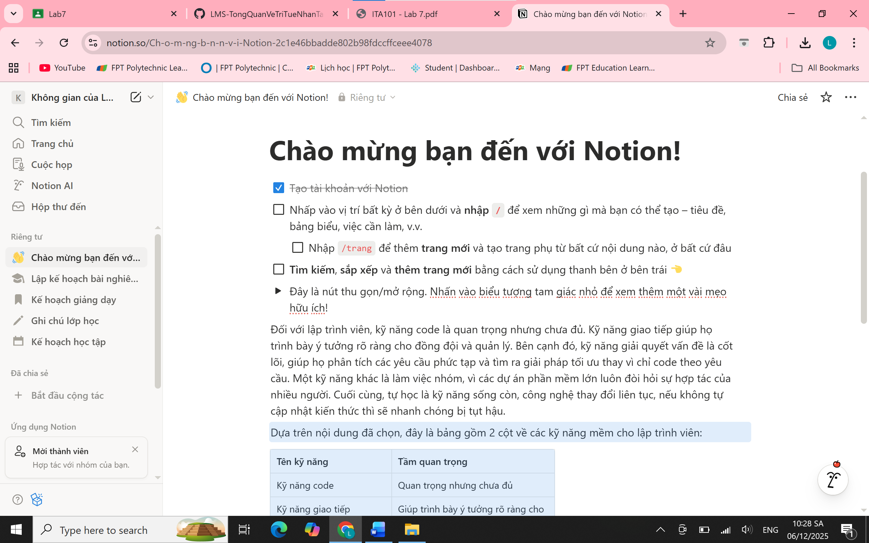
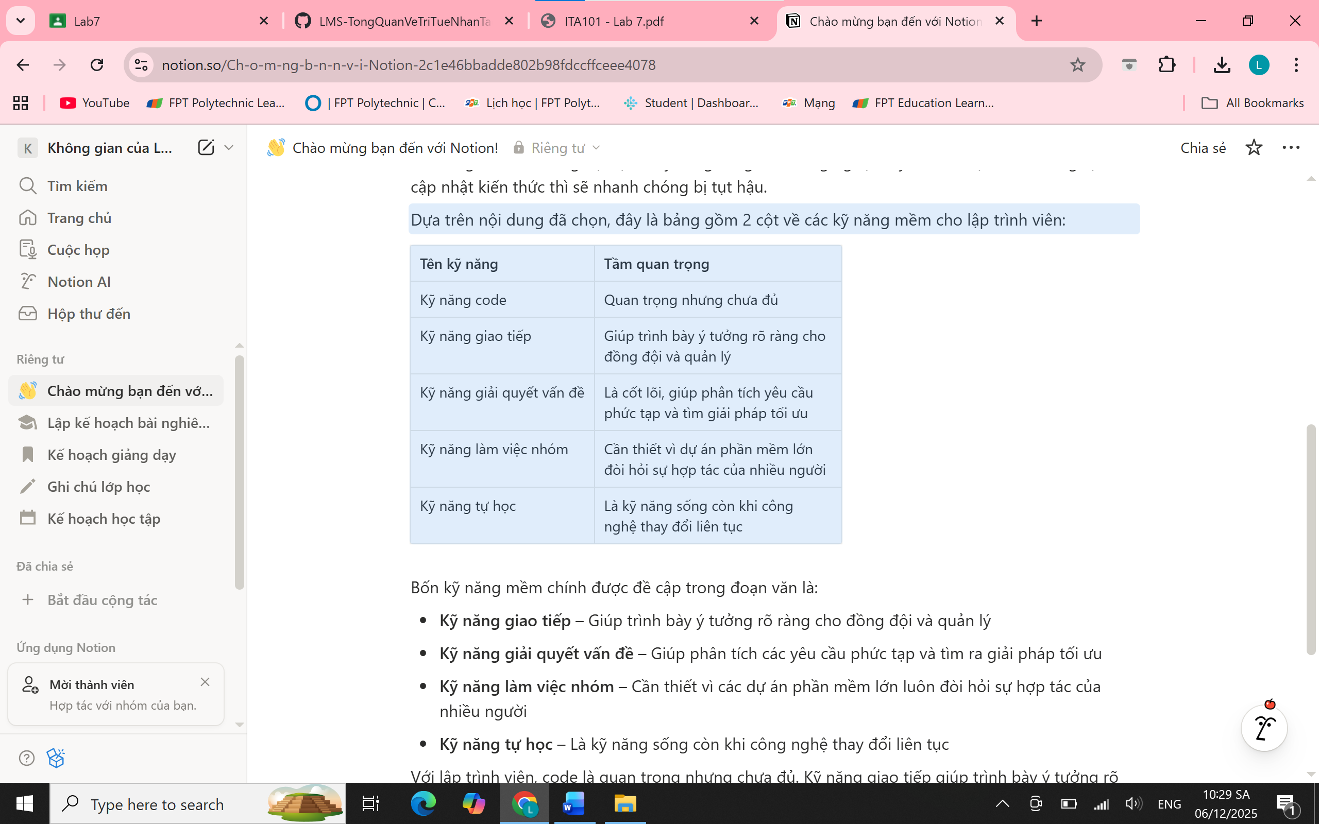
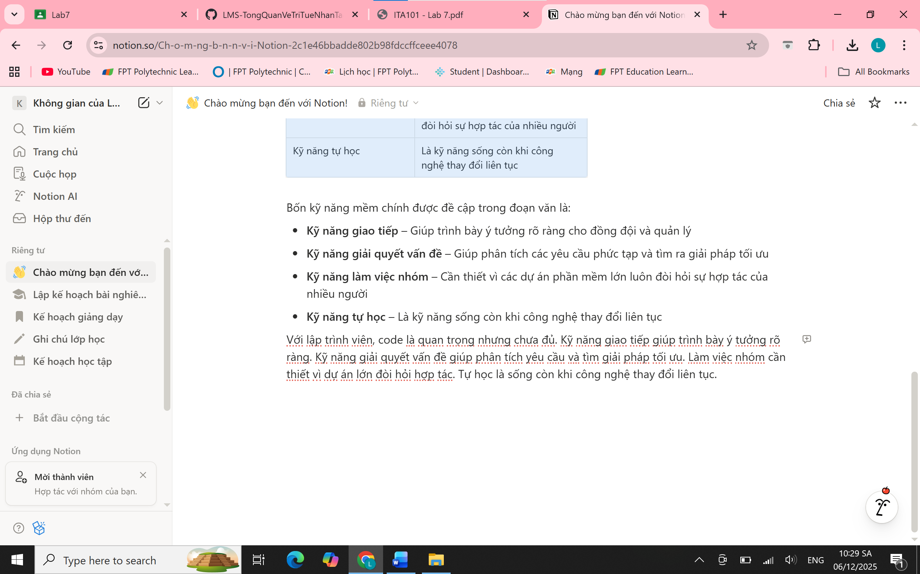

Bài 2
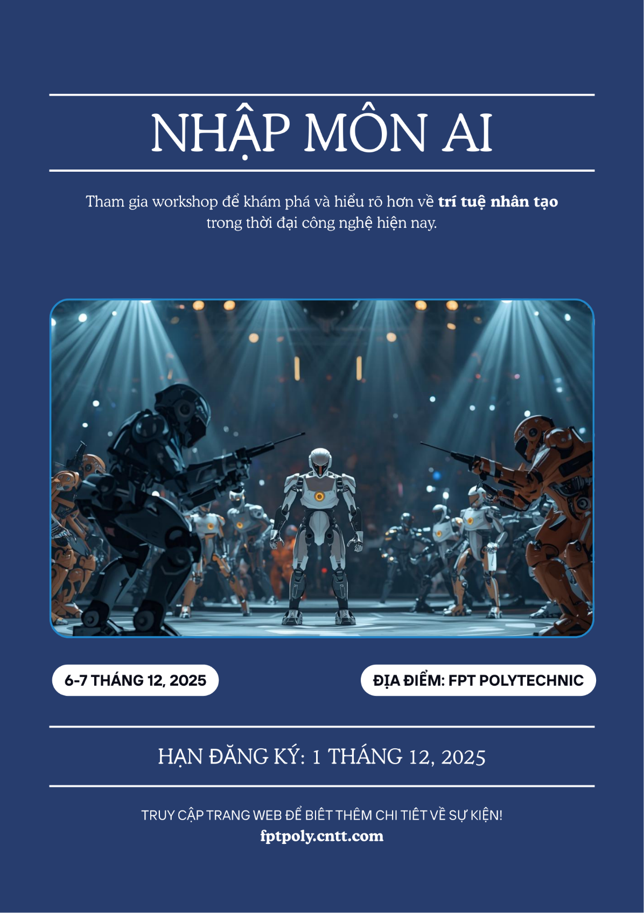

Bài 3
https://gamma.app/docs/Deepfake-va-Nhung-Anh-Huong-en-Xa-Hoi-tp79akskp9bj4sl?mode=doc

